Homework for Lab 2

Exercise 1
In the User’s Guide of Mplus you can find more information on multiple group analyses in Chapter 14 (special modeling issues).
In the file AmerRus.dat the means and (lower triangular) covariance matrices of 86 American students and 66 Russian students are given, which were obtained with the Satisfaction With Life Scale. This questionnaire consists of the following five questions, which were scored on a 7-point Likert scale (1= not at all true, 7 = completely true):
- In most ways, my life is close to ideal
- The conditions of my life are excellent
- I am satisfied with my life
- So far, I have gotten the important things I want in life
- If I could live my life over, I would change almost nothing
We are interested in whether there is a difference in life satisfaction between American and Russian students. The stereotype is that American culture is characterized by optimism while the Russian culture is characterized by melancholy. However, since students have similar lives, they may be quite alike. Before we can compare the two groups of students with respect to life satisfaction, we have to investigate whether measurement invariance holds.
a. How many observed statistics are there?
A: 5 items, so in total: 5 + (5 * 6 / 2) = 20 observed statistics (5 means and 15 unique elements in the covariance matrix) per group
b. If you specify a one-factor model in each group, without any constraints across the two groups, how many parameters are you estimating in total? So how many df will this model have? TIP: do not forget to count the unconstrained means.
A: … Per group, you would be estimating 5 means, 4 factor loadings (the first is fixed to 1), 5 residual variance and 1 factor variance → 5 + 4 + 5 + 1 = 15 free parameters per group
➔ We are left with 20 – 15 = 5 degrees of freedom per group
c. It is not possible to estimate a latent mean. Explain why this is the case, and what is possible with observed and latent means.
A: The reason it is not possible to estimate a latent mean is because by default these are fixed to zero. So we have to free those and constrain other factors in order to be able to estimate them.
With observed means, we can see whether these differences are explained by a mean difference on the latent variables (and not due to a biased test)
d. Indicate how you should specify the DATA command for the two groups and the current data format (see the slides of Lecture 2, and Chapter 15 in the User’s Guide of Mplus on the DATA commands: TYPE, NGROUPS, and NOBSERVATIONS).
A: In MPlus, you should specify the DATA argument in the following way:
DATA: NGROUPS = 2;
TYPE IS MEANS COVARIANCE;
FILE IS AmerRuss.dat;
NOBSERVATIONS ARE 86 66;
VARIABLE: NAMES = IDE EXC SAT GOT CHA;
USEVARIABLES ARE IDE EXC SAT GOT CHA;
e. Define a one-factor model for both groups. For now, do NOT overrule any of the defaults that Mplus imposes in a multiple-group analysis. Ask for the TECH1, run the model, and indicate which parameters were constrained across the groups and which parameters are estimated freely. Indicate what the role of these parameters is in the model (i.e., factor loading relating observed score to latent score, etc.).
A: Constrained across the groups: Nu (the intercepts) and the Lambda’s (the factor loadings) are fixed to be the same across the groups, Alpha (the latent mean of Group 1) is fixed to zero
Freely estimated: alpha of second group, both psi’s, all thetas
f. Define the model for Configural Invariance. Indicate how you adjusted the code of the previous model to overrule Mplus’ defaults. How can you see in the TECH1 output that the defaults were overruled?
A: The model for Configural Invariance looks like the following:
MODEL: LifeSat by IDE EXC SAT GOT CHA;

MODEL G2: LifeSat by IDE@1 EXC SAT GOT CHA;

[LifeSat@0];
[IDE - CHA];
g. Run this model and discuss the model fit.
A:
Chi-square test of model fit(df = 10) = 5.229, p = .8754 → good
RMSEA < .001 → good
CFI/TLI = 1.00 → good
SRMR = 0.024 → good
➔ Overall, the free (i.e., configural) model for both groups fits very well to the data. Which is to be expected as we have barely any constraints.
h. Specify and run the models for weak and strong factorial invariance : Indicate what each model implies, what the df of each model is, and perform appropriate chi-square difference tests (use an alpha of .01), to determine whether the constraints are tenable.
A:
Weak factorial invariance: this model implies equal factor loadings across both groups. This means that 4 less parameters are estimated per group (df = 10 + 4 = 14).
Chi-square test of model fit(df = 14) = 15.240, p = 0.362
➔ Chi-square difference test: 15.240 – 5.229 (df = 4) → p = 0.040
In other words, the constraints of fixing the factor loadings to be equal across both groups is tenable and does not lead to a significant loss of model fit.
Strong factorial invariance: this model implies both equal factor loadings and intercepts across both groups, whilst freeing the latent mean of the second group. This means that 5 – 1 = 4 less parameters are estimated per group (i.e., df = 14 + 4 = 18)
Chi-square test of model fit(df = 18) = 31.214, p = .027
➔ Chi-square difference test: 31.214 – 15.240 (df = 4) → p = .003
In other words, with an alpha of .01, assuming equal intercepts above equal factor loadings across both groups leads to a significant loss of model fit… Hence, we can not assume it and this means that some items might be biased.
i. If one of the chi-square difference tests is significant, what does this mean in substantive terms (i.e., with respect to the comparison of life satisfaction of Russian and American students)? What can be done to compare the two groups?
A: If a chi-square difference test is significant, it means that we cannot assume a certain factorial invariance. This could be due to the fact that some of the items are biased towards one of the groups (such as different intercepts). If this is the case, we can look at the modification indices to see which items have the largest bias and control for this in order to still compare the two groups.
j. Consider the modification indices of the last model. Which ones are of interest for detecting the source of bias? Do you see any need to adjust the model?
A: Looking at the modification indices, we find that the item of ‘gotten the most important things’ and ‘I would change almost nothing’ have the highest values (7 and 8 respectively), this means that allowing their intercepts to differ per group would lead to a significant improvement of model fit and would perhaps allow us to compare the two groups to one another on the latent mean.
k. Adjust your model to account for the bias. Based in this new model, what can you say about the life satisfaction of American and Russian students?
A: Having accounted for the bias introduced by the item of change, we find that the second group (i.e., the Russians) have a latent mean of -0.6. This means that compared to Americans, the life satisfaction of Russian students is on average 0.6 lower.
l) Above you used the Reference-Group method. We also discussed the Marker-variable model. Specify the models for Configural invariance, Weak factorial invariance, and strong factorial invariance for the Marker-variable method (this requires to overrule some defaults in Mplus). Write down the Mplus Model statements for each model. Tip 1: the fit of these models should be identical to the three models used in the Reference-group method, in question 1h. Tip 2: * frees a parameter, whereas @ fixes a variable to a certain value; using the same label constraints parameters to be equal.
A: Marker-Variable model:
Configural invariance:
TITLE: Measurement Invariance Lab
DATA: NGROUPS = 2;
TYPE IS MEANS COVARIANCE;
FILE IS AmerRuss.dat;
NOBSERVATIONS ARE 86 66;
VARIABLE: NAMES = IDE EXC SAT GOT CHA;
USEVARIABLES ARE IDE EXC SAT GOT CHA;
MODEL: LifeSat by IDE@1 EXC SAT GOT CHA;
[IDE@0];
[LifeSat];
MODEL G2: LifeSat by IDE@1 EXC SAT GOT CHA;
[IDE@0];
[LifeSat];
OUTPUT: SAMPSTAT TECH1 TECH4 MOD(4);
Weak factorial invariance:
TITLE: Measurement Invariance Lab
DATA: NGROUPS = 2;
TYPE IS MEANS COVARIANCE;
FILE IS AmerRuss.dat;
NOBSERVATIONS ARE 86 66;
VARIABLE: NAMES = IDE EXC SAT GOT CHA;
USEVARIABLES ARE IDE EXC SAT GOT CHA;
MODEL: LifeSat by IDE@1 EXC SAT GOT CHA;
[IDE@0];
[LifeSat];
MODEL G2: [IDE@0];
[EXC - CHA];
[LifeSat];
OUTPUT: SAMPSTAT TECH1 TECH4 MOD(4);

Strong factorial invariance:
TITLE: Measurement Invariance Lab
DATA: NGROUPS = 2;
TYPE IS MEANS COVARIANCE;
FILE IS AmerRuss.dat;
NOBSERVATIONS ARE 86 66;
VARIABLE: NAMES = IDE EXC SAT GOT CHA;
USEVARIABLES ARE IDE EXC SAT GOT CHA;
MODEL: LifeSat by IDE@1 EXC SAT GOT CHA;
[IDE@0];
[LifeSat];
OUTPUT: SAMPSTAT TECH1 TECH4 MOD(4);
Exercise 2

Check the data file BoysDep.dat: It contains the means, standard deviations and the (lower triangular) correlation matrix for 275 boys on the following four variables (in this order):
- perceived parental rejection (ppr)
- adolescent depression (ad),
- adolescent aggression (aa; note this concerns externalizing problems)
- adolescent withdrawal (aw; note this concerns internalizing problems).

The model of interest can be graphically represented as:

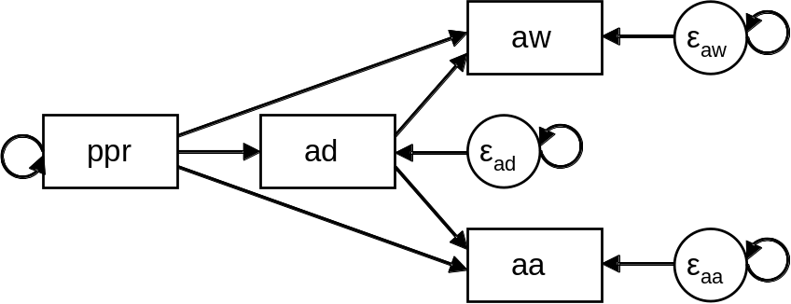

a. Indicate what the model matrices Λ, Ψ, Β, Θ, ν and α look like, and add the parameters to the figure above (if you have trouble determining this from the graph above, you may also run the model first and use the TECH1 output).
A:
Λ = 4 by 4 identity matrix
Ψ = 4 by 4 diagonal matrix that contains residuals (with one covariance that probably shouldn’t be estimated)
Β = 4 by 4 matrix with regression coefficients for the ones we want
Θ = a zero matrix
ν = a zero vector
α = vector with intercepts
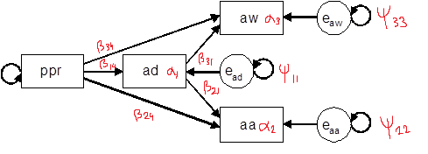
b. How many sample statistics are there, and how many (and which) parameters will be estimated in this model? So how many df will you have?
A: Sample statistics = 4 + 4*5/2 = 4 + 10 = 14
# of parameters estimated = 5 regression coefficients + 3 intercepts + 3 residuals = 11
DF = 14 – 11 = 3
c. The number of cases is 275. Specify the model and run it. Is the number of free parameters correct? Are the df correct?
A: The number of free parameters is 12! Which is not correct. The number of degrees of freedom is 0, which is even weirder because it should be 2 (shouldn’t it?)
TITLE: Measurement Invariance Lab
DATA: FILE IS BoysDep.dat;
TYPE IS MEANS STDEVIATIONS CORRELATION;
NOBSERVATIONS ARE 275;
VARIABLE: NAMES ARE ppr ad aa aw;
MODEL: ad ON ppr;
aw ON ad;
aa ON ad;
MODEL INDIRECT:
aw IND ppr;
aa IND ppr;

OUTPUT: TECH1 STDYX;
d. Apparently, there is a default in Mplus that is active here, causing you to lose a df for a parameter you did not explicitly define. Mplus reports the parameter estimate in the output (under the parameter estimates, but also in the TECH1 output): Which parameter is it? Indicate where this parameter should be drawn in the path diagram, if we were interested in including it.
A: It is Ψ-32, the covariance between the residuals of AW and AA.
e. Adjust the model to overrule this default. How did you do this?
A:
By adding the line: aw WITH aa@0;
We have fixed this covariance between the residuals to 0.
f. Run the model and discuss the model fit.
A: Model fit:
Chi-square test of model fit: 0.750(df = 1), p = .387 (i.e., worse fit)
RMSEA = 0.000 (i.e., good fit)
CFI/TLI = 1.000 (i.e., good fit)
SRMR = 0.014 (i.e., good fit)
➔ Overall, very good model fit.
g. The model contains both direct and indirect effects from perceived parental rejection to adolescent withdrawal and adolescent aggression. Indicate what additional input should be included to obtain information on the direct, indirect and total effects.
A: To receive information on all types of effects, add the following lines in MODEL:
MODEL INDIRECT:
aw IND ppr;
aa IND ppr;
h. Run the model again, asking for the information on these effects. Discuss the results.
A: Looking at the mediation effect of PPR to AW, we find that the mediation seems to be full as the total effect and direct effect are not significant, whereas the total indirect effect most likely is.
As for the mediation effect of PPR to AA, we find that there is a significant total effect, a significant total indirect effect but no significant direct effect. So again, probably full mediation but with a larger effect.
i. When particular paths in your model are nonsignificant, adjust your model for this. How did you change your model? How is the new model related to the old model (in terms of nesting)? Run the new model, and compare it to the previous model.
A: Now the model looks like the following. We simply removed the direct effects of ppr to aw and aa.
MODEL: ad ON ppr;
aw ON ad;
aa ON ad;
aw WITH aa@0;
The model should be nested in the other model, as it is the sample model, but simply more restrictive (namely, no direct effects)
Comparing this model to the old model, we find the following:
Chi-square difference test: 2.497 – 0.750 = 1.75 (df = 3 – 1 = 2), which is not significant! Hence, we can use the more restrictive model as we have no proof against it.
j. For the new model write down the regression equations for the endogenous variables in the model. Include the actual parameter estimates from the output.
A:
AD_i = 1.089 + .609 * PPR_i + e_11i
AW_i = 1.678 + 0.069 * AD_i + e_33i
AA_i = 9.118 + 0.379 * AD_i + e_22i
k. Which adolescent outcome is influenced more by perceived parental rejection: withdrawal or aggression? How did you reach this conclusion?
A: By looking at the standardized regression coefficients, we find that the effect of AD on AA is 0.310 and the effect of AD on AW is 0.200. Hence, the effect of AD on AA is bigger than the effect of AD on AW (and in turn, the effect of PPR on AA is also bigger than the effect of PPR on AW, as the effect of PPR depends on AD).
Exercise 3

Sabatelli and Bartle-Haring (2003) administered two questionnaires. Here we consider data from 103 married couples (heterosexual couples). The first questionnaire is on Marital Adjustment and resulted in the following two subscales:
- Satisfaction: higher scores imply lower levels of complaints
- Intimacy: higher scores imply more self-disclosures, experiences of empathy and affection, and feelings of emotional closeness toward the marital partner
The second questionnaire is on Family of Origin and resulted in the following subscales (higher scores implies better relationships):
- Father: describing the relationship between the participant and his/her father
- Mother: describing the relationship between the participant and his/her mother
- Father-mother: describing the relationship between the parents of the participant
The researchers are interested in the extent to which blue prints that were developed in childhood influence current relationship quality. To this end, a two-factor model can be defined with Family of Origin and Marital Adjustment as the two latent variables of interest, which are assumed to be correlated.

a. Draw a path diagram of this model.
A: 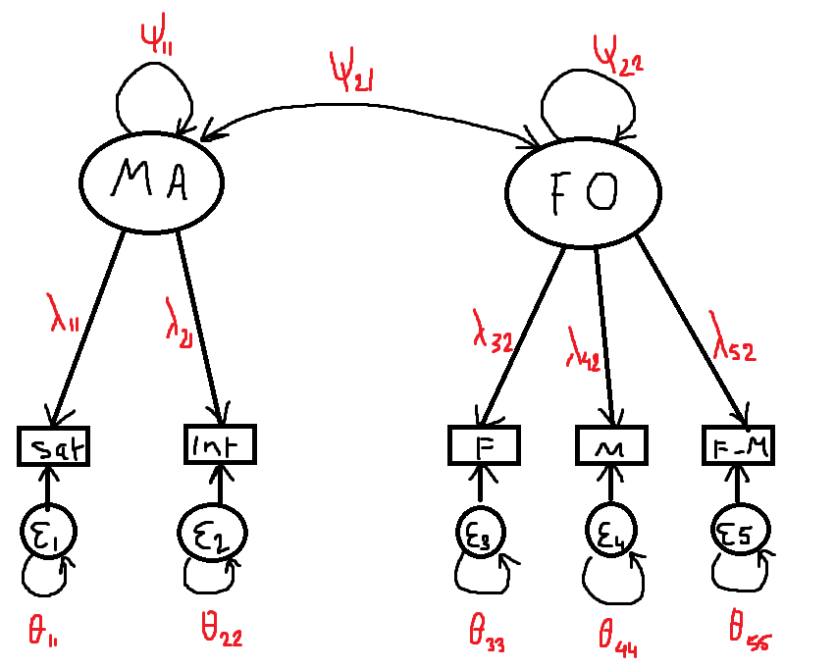
b. If this two-factor model is specified in both groups (husbands and wives), without any constraints across the groups (i.e., configural invariance), how many parameters are estimates? How many observed statistics are there? Hence, how many df are there?
A: Per group:
Sample statistics = 5 + 5*6/2 = 5 + 15 = 20
Parameter estimates = 2 factor variances, 1 factor covariance, 5 residuals, 3 factor loadings (2 for identification), 5 means = 2 + 1 + 5 + 3 + 5 = 16
Degrees of freedom = 20 – 16 = 4
c. The data can be found in the file Family.dat (have a look!): means, sds and correlation matrix of wives, followed by means, sds, and the correlation matrix of husbands.
If you run the model, you will get the following warning:

WARNING: THE RESIDUAL COVARIANCE MATRIX (THETA) IN GROUP G1 IS NOT
POSITIVE DEFINITE. THIS COULD INDICATE A NEGATIVE VARIANCE/RESIDUAL
VARIANCE FOR AN OBSERVED VARIABLE, A CORRELATION GREATER OR EQUAL TO ONE
BETWEEN TWO OBSERVED VARIABLES, OR A LINEAR DEPENDENCY AMONG MORE THAN TWO
OBSERVED VARIABLES. CHECK THE RESULTS SECTION FOR MORE INFORMATION.
PROBLEM INVOLVING VARIABLE INTIMACY.

Check the results (i.e., the parameter estimates): what is the problem?
A: The residual variance of the Intimacy subscale is negative for group 1.
d. The particular problem is referred to as a Heywood case. How could you fix this?
A: A Heywood case tends to indicate either a too small sample size, a non-normal distribution, outliers or a parameter that is so close to a boundary that its estimate exceeded the boundary limit due to sampling fluctuation.
However, we don’t have the raw data so the only thing we could do is increase sample size or look at why it exceeded the boundary limit.
e. For now, you do not need to worry about the Heywood case: Continue with specifying the models for weak factorial invariance and strong factorial invariance. Make sure the df’s are correct (check the TECH1 output to see whether you specified the models correctly). Report on the model fit, and the chi-square difference tests: Is there weak measurement invariance?
A:
Configural invariance: Chi-square = 6 (df = 8)
Weak factorial invariance: Chi-square = 8.7 (df = 11)
➔ Chi-square difference: 8.7 – 6 = 2.7 (df = 3) → non-significant (i.e., we can assume weak factorial invariance)
Strong factorial invariance: Chi-square = 15.65 (df = 14)
➔ Chi-square difference: 15.65 – 8.7 (df = 3) → p = .007 (i.e., we can somewhat assume strong factorial invariance)
f. What can you conclude about the differences between wives and husbands regarding the relationship quality from their family of origin and their marital adjustment?
A: Husbands and wives do not significantly differ in their relationship quality from their family of origin and marital adjustment (diff = -3.140 & -0.415, p = .058 & p = 0.894).
g. The researchers are interested in the effect of family of origin on current relationships. How can you adjust the model to investigate this? How is this new model related to the previous model (i.e., is one nested under the other)?
A: We can investigate this by simply regression Martial Adjustment on Family of Origin.
Whether they are nested under the other, I am unsure. I do not think so as you get different parameters when you regress vs. let correlate.
h. Test whether the effect of family of origin on marital adjustment is the same for wives and husbands. Indicate how you can investigate this, and draw a conclusion.
A: We simply add the line MA on FO under the strong factorial invariance model. We find that for Wives, the regression coefficient is .865 (SE = .232) and for Husbands it is 1.11 (SE = 0.306).
Now, we can simply see whether these two are significantly different through a… t-test?
→ t = (1.11 – 0.865) / (sqrt((.232 + .306) / 2) * sqrt(2 / 103)) = 0.245 / (0.519 * 0.139) = 0.245 / 0.07 = 3.5 (df = 206 – 2 = 204) → significant!
i. You have just run a model that is related to one of the most often used models in the social (and related) sciences: What is it, and how does it differ from the way it is typically done?
A: This is a linear regression with a dummy coded group variable, a continuous variable and an interaction effect. It differs from the way it is typically done because we used a latent continuous variable compared to an observed latent variable.
Exercise 4

In this exercise, we are going to simulate our own data in R, and analyze these in Mplus. You need to download the package mvtnorm, which allows you to randomly draw from a multivariate normal distribution.

Consider the following R-code:

library(mvtnorm)
set.seed(421)

L1 <- matrix(c(1,.5,.5,.5),4,1)
L2 <- matrix(c(.5,.5,.5,.5),4,1)
P1 <- matrix(c(1),1,1)
P2 <- matrix(c(1.2),1,1)
T1 <- diag(c(1,.25,.25,.25))
T2 <- diag(c(.3,.3,.3,.3))

Sigma1 <- L1%*%P1%*%t(L1) + T1
Sigma2 <- L2%*%P2%*%t(L2) + T2

Y1 <- cbind(rmvnorm(200,c(0,0,0,0),Sigma1),rep(1,200))
Y2 <- cbind(rmvnorm(200,c(0,0,0,0),Sigma2),rep(2,200))
Y <- round(rbind(Y1,Y2),4)

write.table(Y,file="multigroup.dat",row.names = FALSE, col.names = FALSE)

a. What is created with this code? What model is used (i.e., what do the model matrices look like)?
A: The code first creates two covariance matrix (L = lambda, P = psi, T = theta). Then, it uses these covariance matrices (with mean structure = 0) to simulate 200 observations on four variables and does this for two groups (1 or 2) and binds them all together in one data frame.

Make sure you have saved the data in the folder where you also have your Mplus input files. Use the following multiple group Mplus code (note how this differs from the code used before, and in the slides, which was appropriate for summary data, whereas now we have the raw data):

TITLE: Model 1
DATA: FILE IS multigroup.dat;

VARIABLE: NAMES = y1-y4 group;
GROUPING IS group (1=male 2=female);

MODEL:
eta BY y1-y4;

MODEL female:
eta BY y2-y4;
[y1-y4];
[eta@0];

OUTPUT: SAMPSTAT TECH1 MOD(0);

b. What can you say about the data type? What model is specified here? What is the model fit?
A: The data type is raw? Furthermore, the model specified here is a one factor model with configural invariance for both groups (i.e., a free model in both groups).
Model fit:
Chi-square = 4.85 (df = 4), p = .30 → good fit
RMSEA = 0.033 → good fit
CFI/TLI = 0.998/0.995 → good fit
SRMR = 0.014 → good fit
➔ The configural model fits good
c. Use y2 for scaling. What code did you use? What is the model fit? Is this surprising?
A:
MODEL:
eta BY y2 y1 y3 y4;
MODEL female:
eta BY y2@1 y1 y3 y4;
[y1-y4];
[eta@0];
➔ Model fit is exactly the same, which is not surprising as it does not matter which item you use for scaling.
d. Introduce the constraints for Weak Factorial Invariance, using the first way of scaling. What are the constraints? What is the model fit? What do you conclude about this constraint?
A:
Model fit:
Chi-square = 37.64 (df = 7)
RMSEA = 0.148, CFI = 0.937, SRMR = 0.080
➔ We can not assume weak factorial invariance (i.e., equal factor loadings)
e. Do the same for the other way of scaling. What is the model fit, and what is your conclusion about the constraint? Does this surprise you?
A:
Model fit:
Ch-square = 37.64 (df = 7),
RMSEA = 0.148, CFI = 0.937, SRMR = 0.080
➔ We can not assume weak factorial invariance.
f. Consider the modification indices for the models in d and e: What is your conclusion?
A:
from model d)
ETA BY Y1 28.017 0.967 0.602 0.455
ETA BY Y2 8.570 -0.210 -0.130 -0.180
from model e)
ETA BY Y1 28.006 0.886 0.458 0.347
ETA BY Y2 8.569 -0.427 -0.221 -0.304
➔ No matter the scaling, item y1 seems to be the largest cause of non-uniform bias on the latent variable between the two groups.
g. What have you learned from this exercise?
A: That scaling really does not matter.

